
Geometry Reflective Portfolio Unit #8: Geometric measurement
Section #1: Vocabulary (words and/or diagrams)
Apex | Cavalieri’s Principle:
Cross-section
Edge | Skew lines
Face | Slant height
Density | Vertex (corner)
Polyhedron | Volume
Section #2: Formulas/Equations/Theorems
Figure | Formula | 3D solid diagram | Net
triangle | Area:
circle | Circumference:  Area:
Prism | Volume: | Rectangular prism  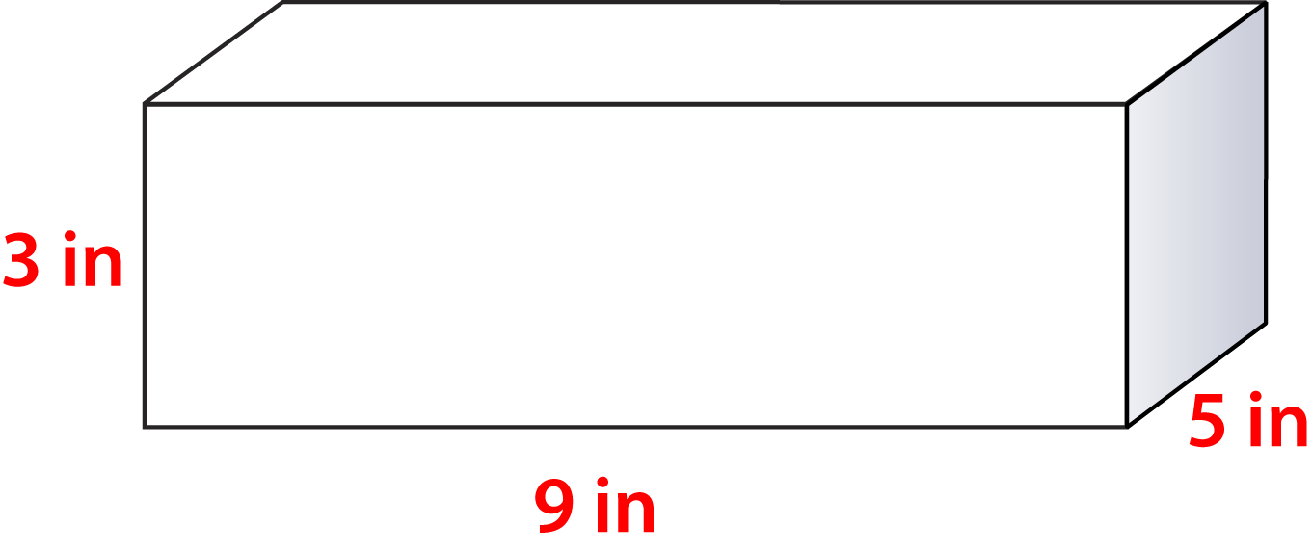 | Rectangular prism
Pyramid | Volume: | Rectangular Pyramid  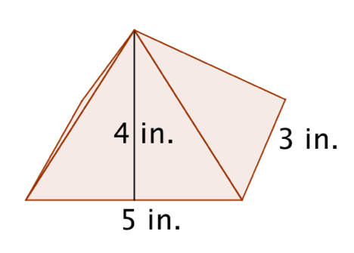 | Rectangular Pyramid
Right cylinder | Volume: | 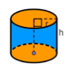
Right cone | Volume: | 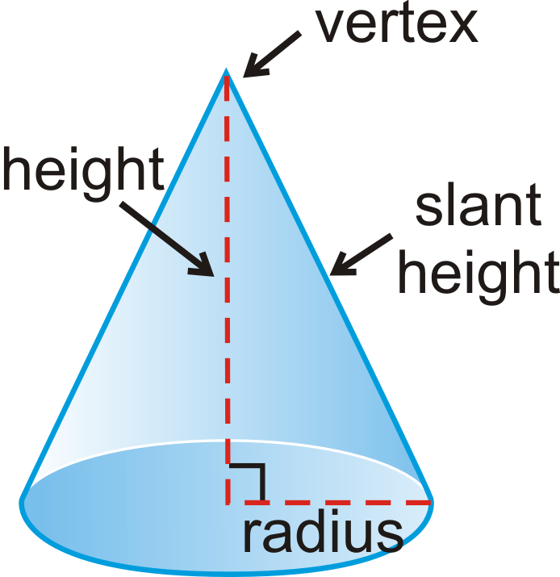
Sphere | Volume: | 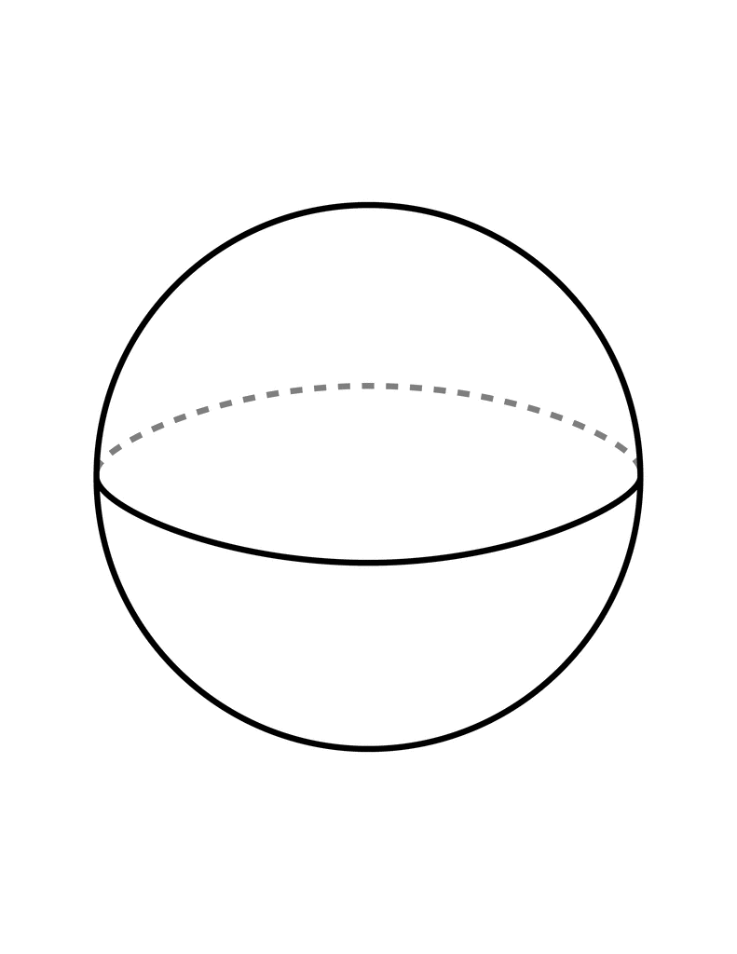

3D solid | Number of faces | Number of edges | Number of vertices | Cross-sections
Rectangular Prism |  |  |  | Parallel to base: | Vertical to base:
Regular Pyramid |  |  |  | Parallel to base: | Vertical to base:
Right cylinder |  |  |  | Parallel to base: | Vertical to base:
Right cone |  |  |  | Parallel to base: | Vertical to base:
Sphere |  |  |  | Parallel to base: | Vertical to base:

Section #3: Key methods and concepts
(Show your work to solve for each example below) No work, No credit!

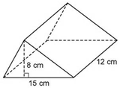  Example #1: Find the volume of this prism.  ans. 720cm³ | Example #2: Find the difference in the volumes in terms of pi for a right cone and a right cylinder that have a base with diameter 20 in. and vertical height of 15 in. ans. 1000π
Example #3: If the volume of this pyramid is 720m³, find the height. ans. 15m  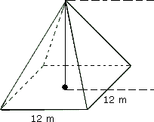  h | Example #4: Brett has a full container of ice cream which has a density of 0.01 pounds per cubic inch. The container is a cylinder which has a radius of 4 inches and a height of 5 inches. Becky also has a full container of ice cream, which has a density of 0.01 pounds per cubic inch and is contained in a cylinder which has a radius of 3 inches and a height of 6 inches. Calculate who has more ice cream and by how many pounds, to the nearest tenth of a pound?  Brett does by about 0.8
Example #5:  Lines AB and HG are___________________ lines.  Lines EC and AD are ____________________ lines.  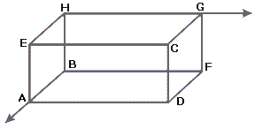 | Example #6: Petri dish A has a radius of 5 cm with number of bacteria equal to 1.6 x10⁵ and petri dish B has a radius of 4 cm with number of bacteria 6.1 x10⁴. Determine the population density for each to the nearest tenth of a square cm. and state which dish has the greater bacteria population density?  Sample A has a greater density ( 824 bacteria more).

