**Geometry CC Reflective Portfolio Complete this and study!**

**Unit #1: Constructions/Prerequisite skills Use your notes…DO NOT GUESS!!!**

**Section #1: Vocabulary (definitions) Use words and/or Draw**

|  |  |  |
| --- | --- | --- |
| **Angle bisector** | **Altitude** | **Perpendicular bisector** |
| **Median** | **Parallel lines** | **Perpendicular lines** |
| **Circumscribe** | **Inscribe** | **Congruent** |
| **Midpoint** | **Acute triangle** | **Obtuse triangle** |
| **Right triangle** | **Scalene triangle** | **Isosceles triangle** |

**Section #2: Formulas/Equations/Theorems**

**Write each formula AND show work for each example: (-2, 5) and (6, 10)**

**Ex. 1 Slope: ans. **

**Point-slope form of a line:________________________________**

**Ex. 2 ) Line passing through (2, 3) and parallel to **

**Slope-intercept form of a line:_____________________________**

**Ex. 3) Line passing through (0, 3) and perpendicular to **

**Algebra 1 review: radicals**

**YOU MUST SHOW WORK to receive credit!**

**Ex. 4 Simplify $\sqrt{160}$ Ex. 5 Simplify $(\sqrt{10 })(\sqrt{2})$ Ex. 6 $\sqrt{3}$ + $\sqrt{48}$ + $\sqrt{18}$**

***Ans. $4\sqrt{10}$ Ans. 2 $\sqrt{5}$ Ans. $5\sqrt{3}+3\sqrt{2}$***

**Pythagorean theorem: YOU MUST SHOW WORK to receive credit!**

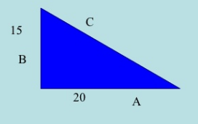**Ex. 7 Find the value of C . Ex. 8 Find the length of unknown leg.**

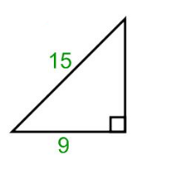

***Ans.C = 25 Ans. 12***

**Distance and Midpoint formulas: USE your notes to write each correctly!!!!!**

**Write the Distance formula:**

**Ex. 9 Find the distance from (-2, 7) to (4, 9) in simplest radical form.**

**Ans. 2 $\sqrt{10}$**

**Write the Midpoint formula:**

**Ex. 10 Find the midpoint of $\overline{FX}$ with F(-1, 8) and X(11, 4)**

**Ans. (5, 6)**

**Section #3: Key methods and concepts Need help? Mathopenref.com**

1. **Copy segment AB. 2) Bisect segment AB.**

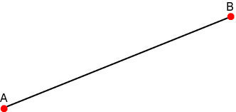****

1. 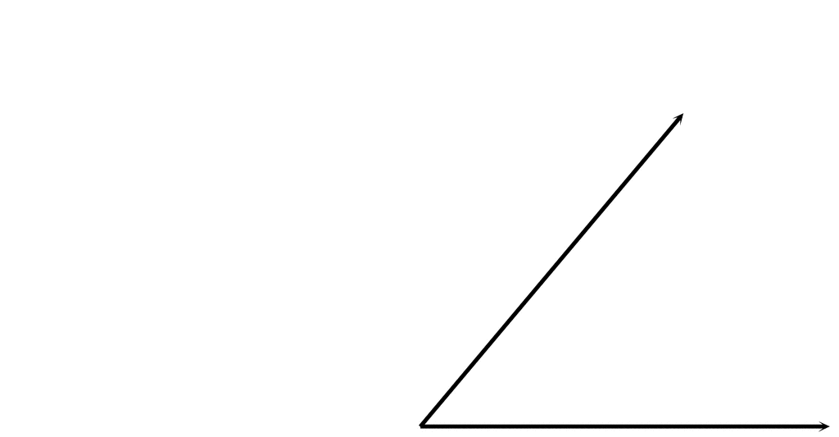**Copy the angle.**

**4) Bisect the angle.**



1. **Construct a line through point P that is perpendicular to the given segment.**

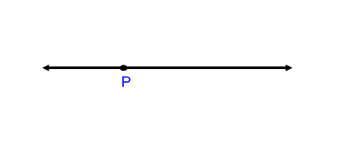

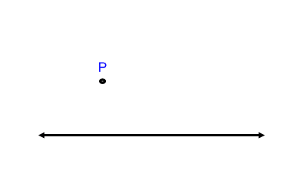

1. **Construct a line through point P that is perpendicular to the given segment.**
2. **Construct the median from A to BC.**

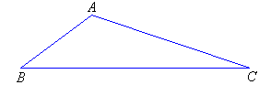

1. **Construct the altitude from A to BC**



1. **Construct a line which passes through point R and is parallel to line QP.**

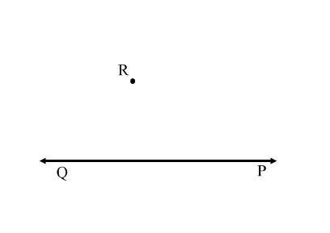

**10) Construct an isosceles triangle that is not equilateral.**

**11) Inscribe an equilateral triangle in a circle.**

**12) Inscribe a regular hexagon in a circle.**